University of Washington
Central Receiving Program Overview

What:
The University is undertaking multiple initiatives to improve efficiency across the institution. One of these is to deploy Central Receiving capabilities across all campuses of Workday Purchase Order packages. Central Receiving encompasses moving from our current decentralized environment where all suppliers ship directly to buildings on campus, to having all suppliers ship directly to initially one primary Central Receiving Hub across campus.
Why:
The primary reasons for action are to capture operational efficiencies by:
- Standardizing physical and systematic (Workday) receiving practices
- Eliminating the need for Requisition Requisitioners to perform receiving tasks including Create Receipt and management of packing slips
- Increasing end-to-end order visibility by including all order and shipment documentation, including POs, Invoices, Receipts, and Packing Slips in Workday
- Improving financial controls by eliminating reliance on supplier provided Advanced Ship Notices
- Reducing aged invoices due to delays in receipt creation
Who:
Financial Planning & Budgeting (FPB) in partnership with Workday Finance Application Management (FAM) team are responsible for jointly deploying this capability. The key stakeholders include all Colleges, central office departments, and particularly all Shared Environment personnel who perform purchasing and receiving activity.
When:
The initial deployment of Central Receiving practices began in March of 2026 on our UW Tacoma campus, with the anticipated initial deployment on the Seattle campus beginning in April of 2026. Deployment is by building with monthly “waves” of deployment containing a logical selection of 20 – 30 buildings. Deployments will continue monthly until all in scope buildings are deployed, with a target completion of December 2026.

What’s Changing?
The primary changes this will bring to stakeholders are:
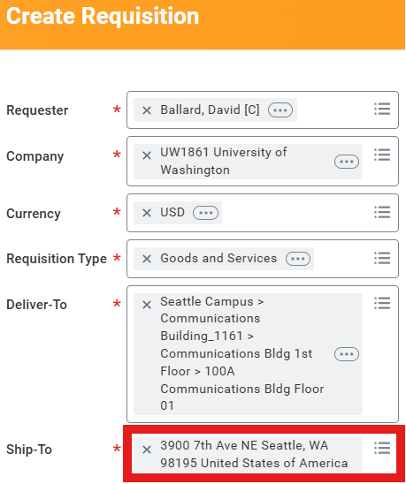
Workday Requisitions
- There is NO operational change in the requisitioning process. Selecting the appropriate Deliver-To when creating a requisition will still auto-populate the Ship-To address.
- However, the official “ship to” address for your building will be changed in Workday from your current ship to address to the address of the Central Receiving Hub, the Publications Services Building (3900 7th Ave NE). You will see this change on the Create Requisition screen (see example to the right).
- This ship to address will be sent to the supplier and will be on the supplier’s shipping label to ensure delivery to the Central Receiving Hub

Receiving Process
- Physical and systematic (Workday) receiving will now be executed by Creative Communications staff in the Publication Services Building being managed by Creative Communications (C2). This eliminates the need for requisition requesters to Create Receipt in Workday, and eliminates the need to manage and track packing slips.
- The C2 team will now Create Receipt in Workday and as part of their process they will also scan in the packing slip which will be attached to the Receipt and available for viewing and downloading if desired.
- The final part of the C2 process will also track delivery stages from receipt through delivery as they deliver packages daily to your agreed to deliver to locations.

Exception Processing
- This will be explained in detail in another document and at your monthly Wave meeting. However, another significant process enhancement is the development of a ticketing system to actively track exceptions (wrong quantity, wrong product, damaged product, etc.)

Where to Find Additional Information
- C2 has created a Central Receiving website which can be found here: c2.washington.edu/centralreceiving
- This site will include the deployment Wave Board, more detailed information on the happy path and exception processes, PowerPoint decks to aid in educating your people, communication aids such as this document, and metrics to show how we are all progressing.

How You Can Help
- Monitor: Monitor the monthly “Wave” board to see if your building will be in scope for the next deployment wave. Wave selections will be made available 4 – 6 weeks prior to the deployment month. The deployment board can be seen here: c2.washington.edu/centralreceiving
- Select: For all departments, especially if you’re selected for the next wave, identify key points of contact who need to be involved from a deployment planning perspective. These points of contact can be provided here: c2.washington.edu/centralreceiving
- Attend: Unfortunately we will not be able to meet one on one with each building in a given wave. But we will have recurring monthly wave deployment meetings and office hours to share the process and get frequently asked questions answered. So please ensure your key points of contact attend the regularly scheduled monthly deployment meeting to better understand the deployment process and get their specific questions answered
- Communicate: Please help cascade out communications to key stakeholders in your specific areas of responsibility.

